CHAPTER 5 ESTIMATION AND COSTING

5.1 Product cost determination,

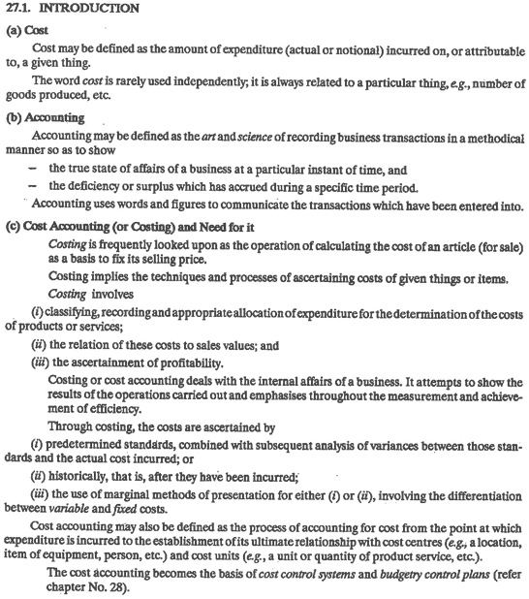

Direct Cost and Indirect Cost,

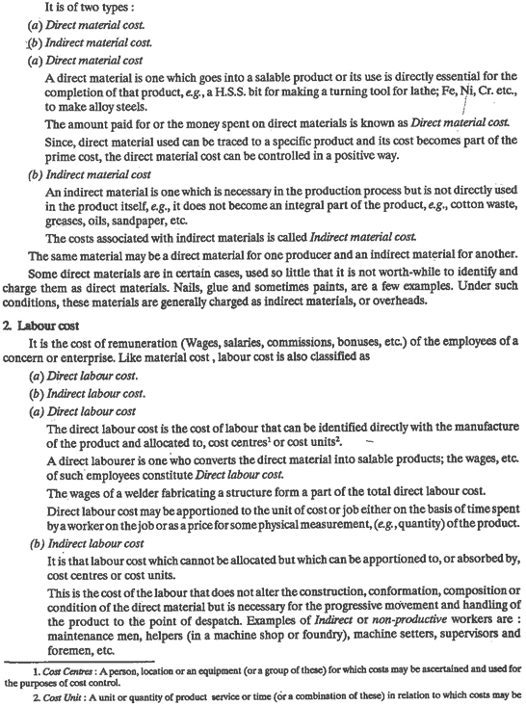

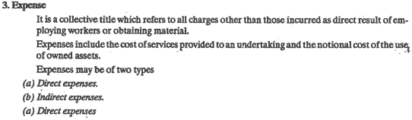

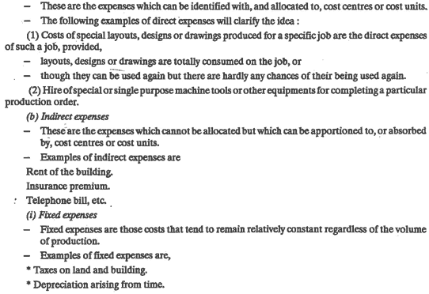



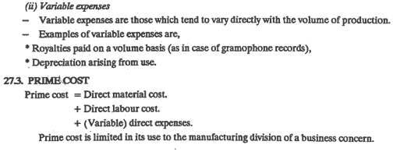

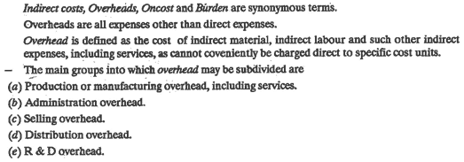Overheads

Material

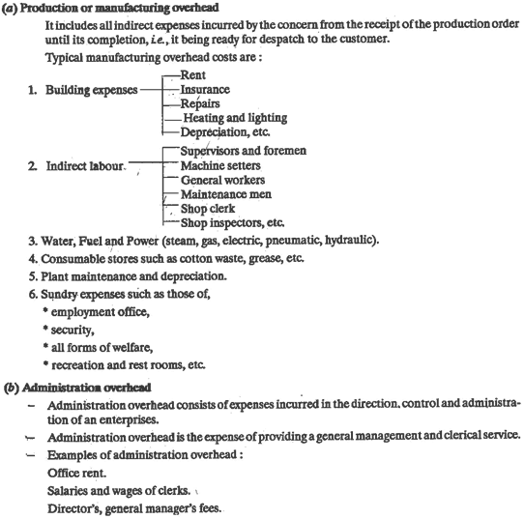

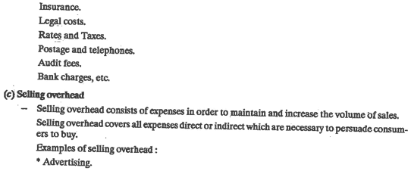



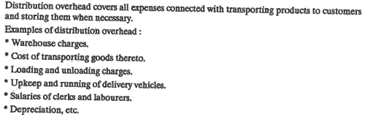

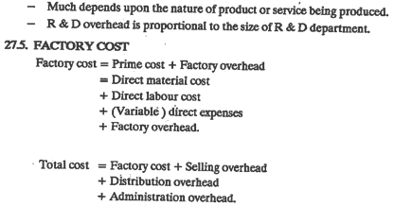



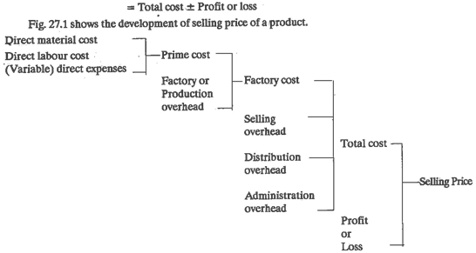

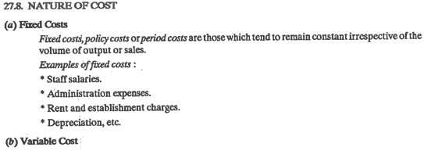

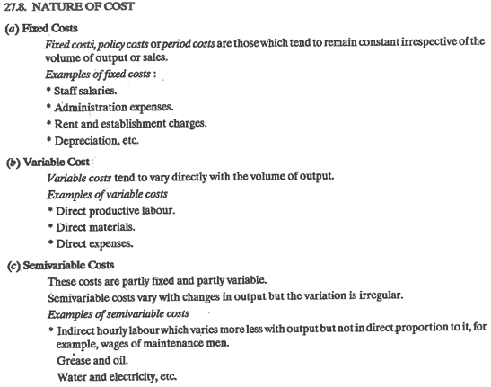



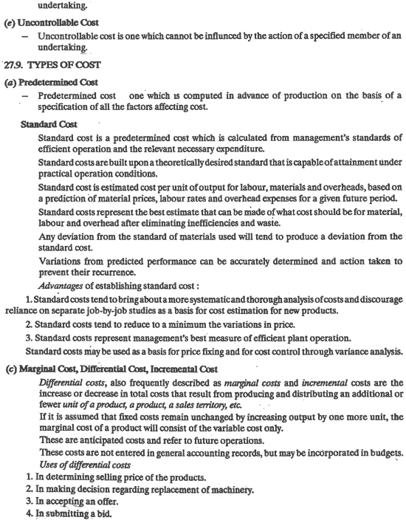

5.2 Determination of Selling Price of product

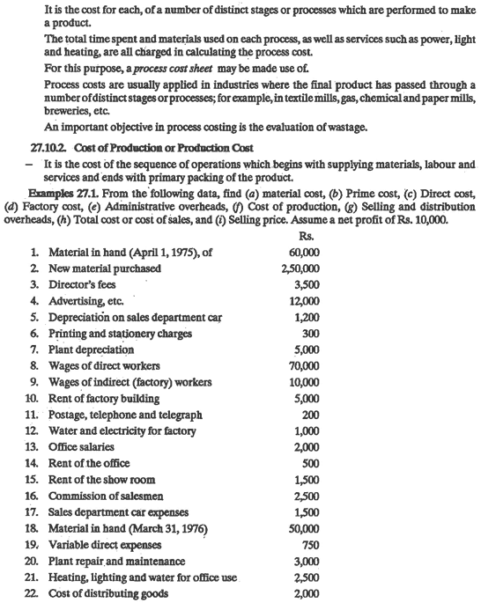

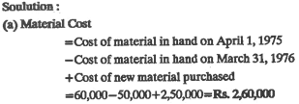

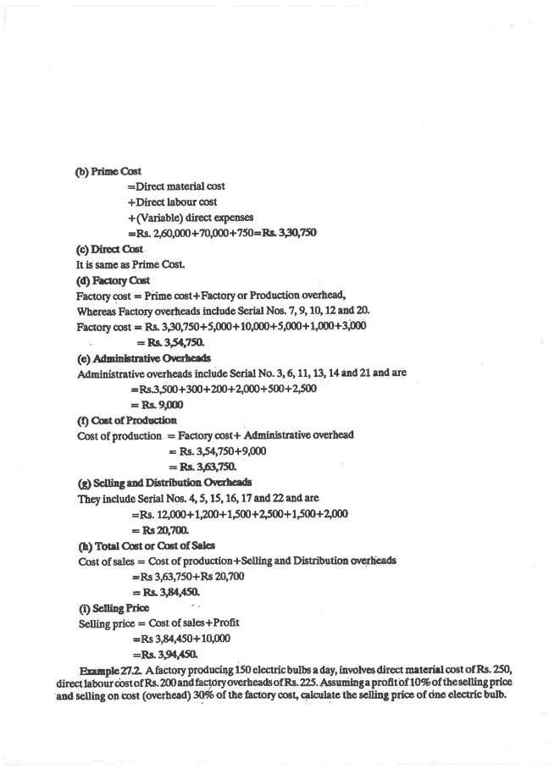

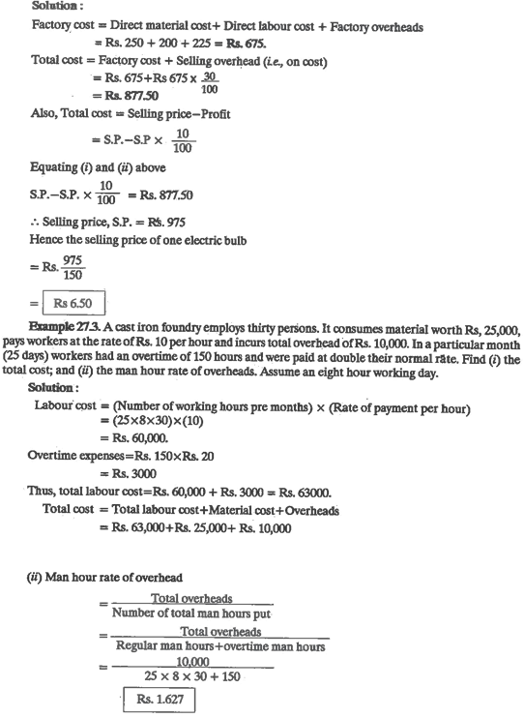

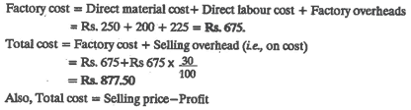

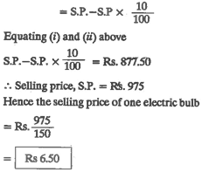

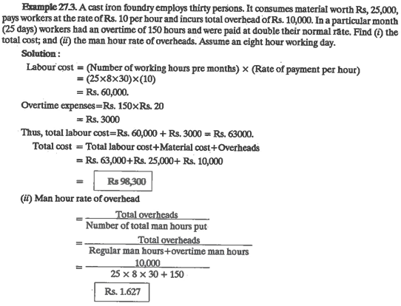

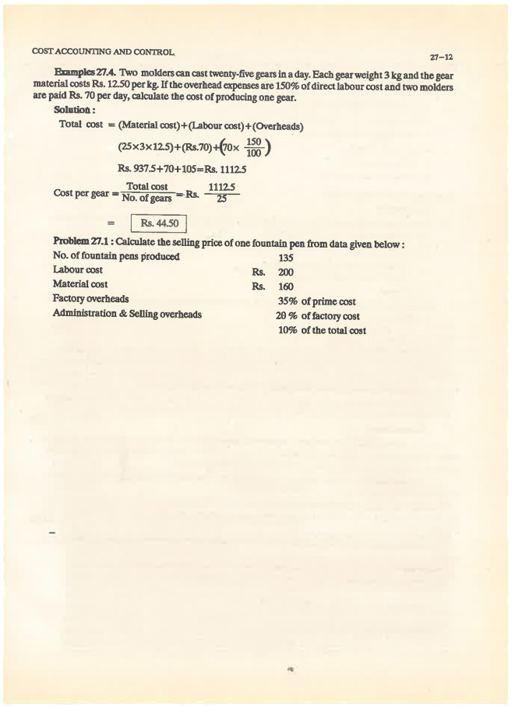

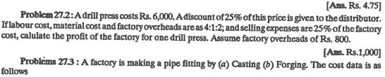

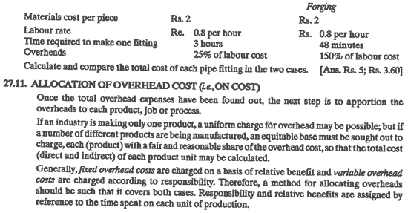

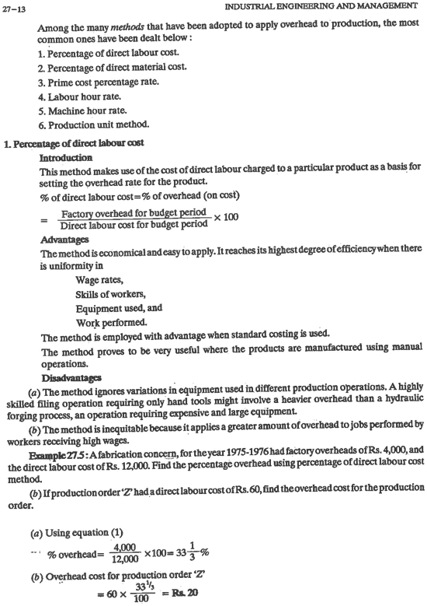

.

- Profit and Loss Statement,

What is a Profit and Loss Statement (P&L)?

The profit and loss (P&L) statement is a financial statement that summarizes the revenues, costs and expenses incurred during a specified period, usually a fiscal quarter or year. The P&L statement is synonymous with the income statement. These records provide information about a company's ability or inability to generate profit by increasing revenue, reducing costs or both. Some refer to the P&L statement as a statement of profit and loss, income statement, statement of operations, statement of financial results or income, earnings statement or expense statement.

Balance Sheet consist of

* **Assets**
* **Liabilities**
* **Owner's (Stockholders') Equity**

### Assets

[Current assets](https://en.wikipedia.org/wiki/Current_asset)

1. [Accounts receivable](https://en.wikipedia.org/wiki/Accounts_receivable)
2. [Cash and cash equivalents](https://en.wikipedia.org/wiki/Cash_and_cash_equivalents)
3. [inventories](https://en.wikipedia.org/wiki/Inventory)
4. Cash at bank, Petty Cash, Cash On Hand
5. [Prepaid expenses](https://en.wikipedia.org/wiki/Prepaid_expenses) for future services that will be used within a year
6. Revenue Earned In Arrears (Accrued Revenue) for services done but not yet received for the year
7. Loan To (Less than one financial period)

[Non-current assets](https://en.wikipedia.org/wiki/Non-current_assets) ([Fixed assets](https://en.wikipedia.org/wiki/Fixed_asset))

1. [Property, plant and equipment](https://en.wikipedia.org/wiki/Property,_plant_and_equipment)
2. Investment property, such as [real estate](https://en.wikipedia.org/wiki/Real_estate) held for investment purposes
3. [Intangible assets](https://en.wikipedia.org/wiki/Intangible_asset) such as (patents, copyrights and goodwill)
4. Financial assets (excluding investments accounted for using the equity method, [accounts receivables](https://en.wikipedia.org/wiki/Accounts_receivable), and cash and [cash equivalents](https://en.wikipedia.org/wiki/Cash_equivalents)), such as [notes receivables](https://en.wikipedia.org/wiki/Notes_receivable)
5. [Investments](https://en.wikipedia.org/wiki/Investments#Finance) accounted for using the [equity method](https://en.wikipedia.org/wiki/Equity_method)
6. Biological assets, which are living plants or animals. Bearer biological assets are plants or animals which bear agricultural produce for harvest, such as apple trees grown to produce apples and sheep raised to produce wool.[[16]](https://en.wikipedia.org/wiki/Balance_sheet#cite_note-16)
7. Loan To (More than one financial period)

**Liabilities**

1. [Accounts payable](https://en.wikipedia.org/wiki/Accounts_payable)
2. [Provisions](https://en.wikipedia.org/wiki/Provision_(accounting)) for warranties or court decisions (contingent liabilities that are both probable and measurable)
3. Financial liabilities (excluding provisions and [accounts payables](https://en.wikipedia.org/wiki/Accounts_payable)), such as [promissory notes](https://en.wikipedia.org/wiki/Promissory_note) and [corporate bonds](https://en.wikipedia.org/wiki/Corporate_bond)
4. Liabilities and assets for current [tax](https://en.wikipedia.org/wiki/Tax)
5. [Deferred tax](https://en.wikipedia.org/wiki/Deferred_tax) liabilities and deferred tax assets
6. Unearned revenue for services paid for by customers but not yet provided
7. Interests on loan stock

**Equity / capital**

The net assets shown by the balance sheet equals the third part of the balance sheet, which is known as the [shareholders' equity](https://en.wikipedia.org/wiki/Shareholders%27_equity). It comprises:

1. Issued capital and [reserves](https://en.wikipedia.org/wiki/Reserve_(accounting)) attributable to equity holders of the [parent company](https://en.wikipedia.org/wiki/Parent_company) (controlling interest)
2. [Non-controlling interest](https://en.wikipedia.org/wiki/Minority_interest) in equity

Formally, shareholders' equity is part of the company's liabilities: they are funds "owing" to shareholders (after payment of all other liabilities); usually, however, "liabilities" is used in the more restrictive sense of liabilities excluding shareholders' equity. The balance of assets and liabilities (including shareholders' equity) is not a coincidence. Records of the values of each account in the balance sheet are maintained using a system of accounting known as [double-entry bookkeeping](https://en.wikipedia.org/wiki/Double-entry_bookkeeping). In this sense, shareholders' equity by construction must equal assets minus liabilities, and thus the shareholders' equity is considered to be a residual.

Regarding the items in equity section, the following disclosures are required:

1. Numbers of [shares](https://en.wikipedia.org/wiki/Share_(finance)) authorized, issued and fully paid, and issued but not fully paid
2. [Par value](https://en.wikipedia.org/wiki/Par_value) of shares
3. Reconciliation of shares outstanding at the beginning and the end of the period
4. Description of rights, preferences, and restrictions of shares
5. [Treasury shares](https://en.wikipedia.org/wiki/Treasury_share), including shares held by [subsidiaries](https://en.wikipedia.org/wiki/Subsidiary) and associates
6. Shares reserved for issuance under [options](https://en.wikipedia.org/wiki/Option_(finance)) and [contracts](https://en.wikipedia.org/wiki/Contract)
7. A description of the nature and purpose of each reserve within owners' equity

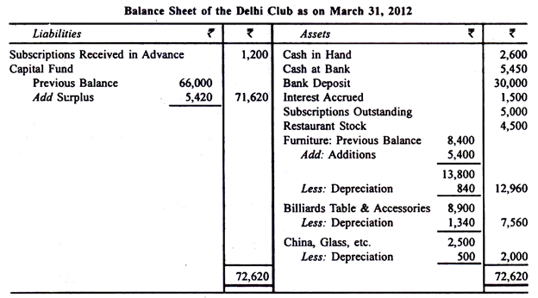

5.3 Depreciation &, Obsolescence- Concept and Comparison.

**Obsolescence** occurs generally due to the availability of alternatives that perform better or are cheaper or both, or due to changes in user preferences, requirements, or styles. It is distinct from fall in value (**depreciation**) due to physical deterioration or normal wear and tear

Difference between Depreciation &, Obsolescence.

Depreciation means reduction of value of an asset due to wear and tear. It happens over the life of an asset.

Obsolecence means reduction of value as the asset is outdated.

For example, consider a machine with useful life of 10 years. It will be depreciated over the period of 10 years as there will be physical deterioration and wear and tear of the machinery.

Assume, after 6 years, a new technology has come up, due to which the organisation/company no longer use this machinery. Then it is obsolescence.

Floppy discs and video cassette recorders (VCRs) can be good examples for obsolescence.





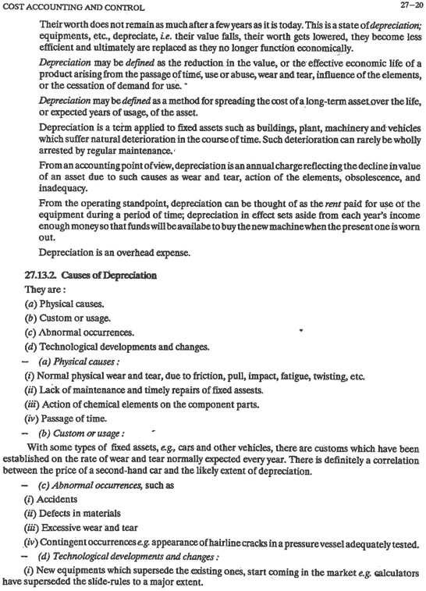

5.4 Methods of Calculating depreciation- straight line, reducing balance, annuity, sinking fund & sum of the digit methods. ( SimpleNumericals on subtopic 5.1, 5.2 & 5.4 )

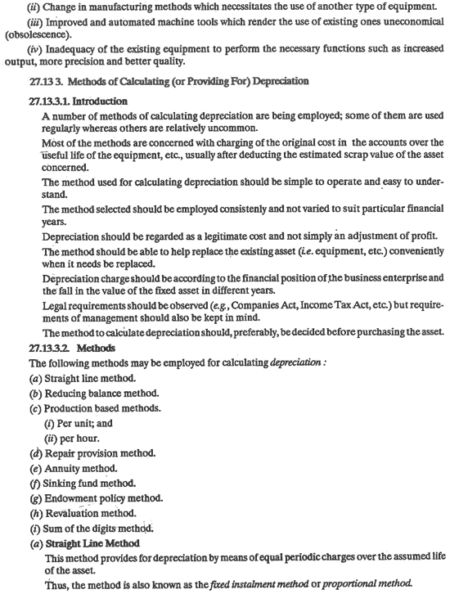

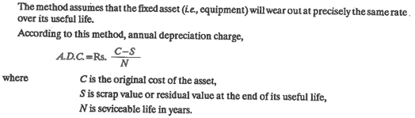

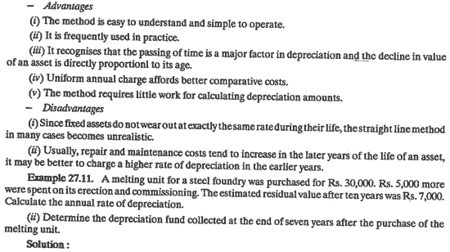

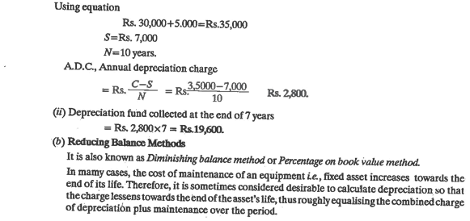

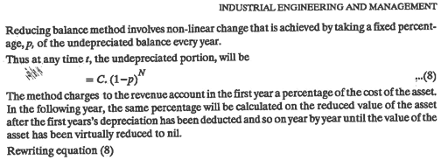

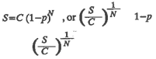

=

P=1-(S/C)1/N

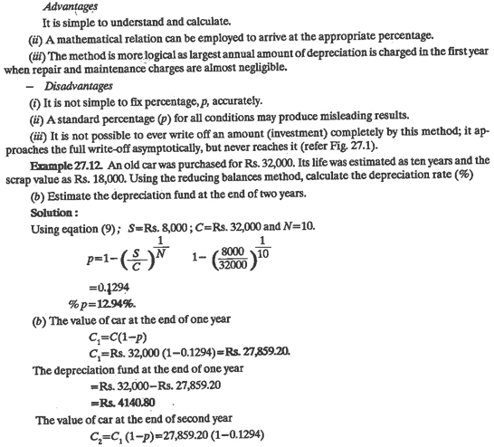

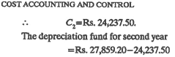



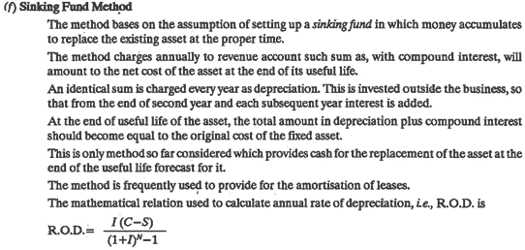

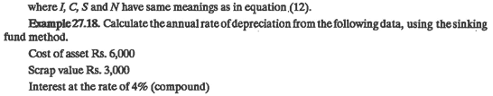



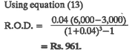

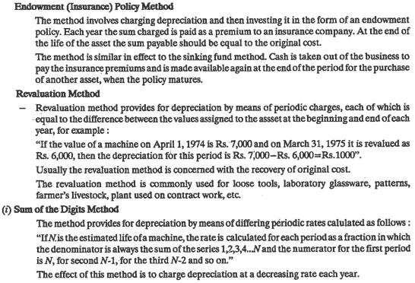

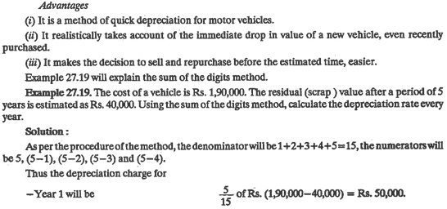

Year2 4/15 x 150000=40000

Year 3 3/15 x 150000=30000

Year 4 2/15 x 150000=20000

Year 5 1/15 x 150000=10000



